

**SWS213LecCNET/NET320LecNET Database Systems**

**Spring 2018**

**Lab 1a**

**Introduction to MySQL** **& Installing MySQL Server 5.7**

# Objectives

The objective of this lab is to familiarize with MySQL. Installing MySQL server 5.7.

# Background

**MySQL Database**

MySQL is the world’s most popular open source database for cost-effectively delivering reliable, high performance and scalable e-commerce, online transaction processing, and embedded database applications. It is an integrated, transaction safe, ACID−compliant database with full commit, rollback, crash recovery, and row-level locking capabilities. MySQL delivers the ease of use, scalability, and high performance, as well as a full suite of database drivers and visual tools to help developers and DBAs build and manage their MySQL applications. The MySQL Database provides the following features:

• High Performance & Scalability to meet the demands of exponentially growing data loads and users.

• Self-healing Replication Clusters to improve scalability, performance and availability.

• Online Schema Changes to meet changing business requirements.

• Performance Schema for monitoring user & application level performance and resource consumption.

• SQL & NoSQL Access for performing complex queries and simple, fast Key Value operations.

• Platform Independence giving you flexibility to develop and deploy on multiple operating systems.

• Big Data Interoperability using MySQL as the operational data store for Hadoop and Cassandra

# Software Required

MySQL server 5.7.

# References

# *https://dev.mysql.com/downloads/mysql/*

**Installing MySQL Server 5.7**

1. Uninstall the previous version of MySQL.
2. Reboot the system.
3. Follow the link https://dev.mysql.com/downloads/windows/installer/5.7.html to download MySQL Server 5.7.
4. Select MySQL Community Server version as **5.7.21** and platform as **Microsoft Windows.**
5. Select the zip archive according to your operating system.
6. Select on *‘No thanks, just start my download’*

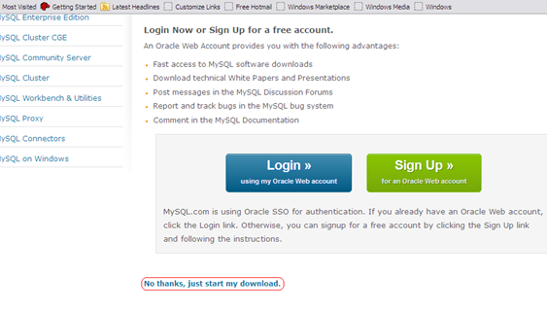

1. Save the file.
2. Run the saved file.
3. Click ‘*Next*’ on the MySQL Server setup.
4. Accept the license agreement and click on ‘Next’

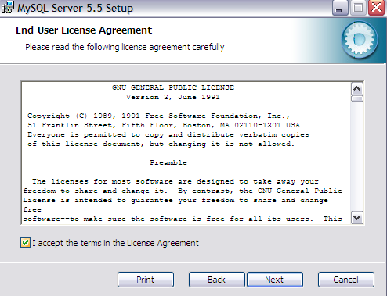

1. Select ‘*Complete*’ installation.

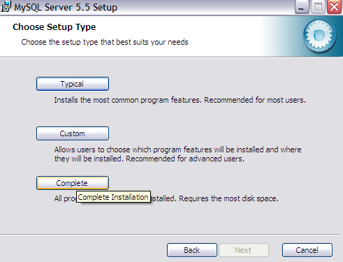

1. Select the ‘*Install*’

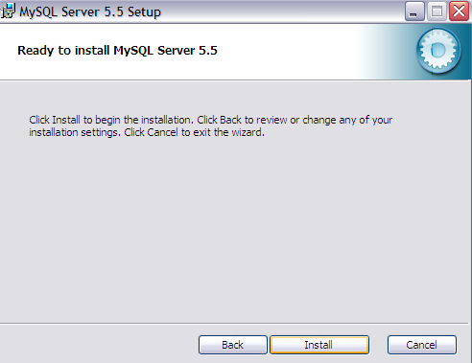

1. The installation will take a few minutes based on your computer.

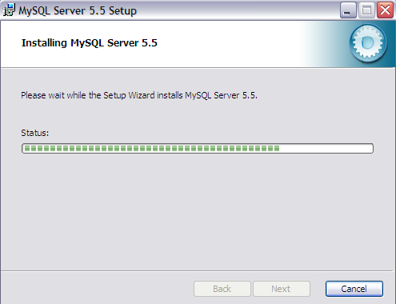

1. Click on ‘Finish’ to complete the installation.

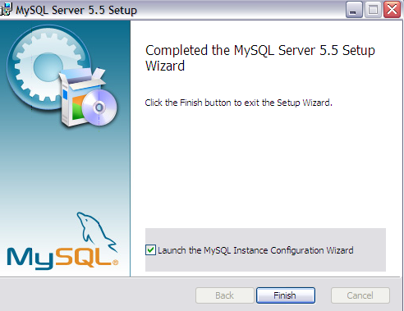

1. Click ‘*Next*’ on the MySQL Server Instance Configuration Wizard.

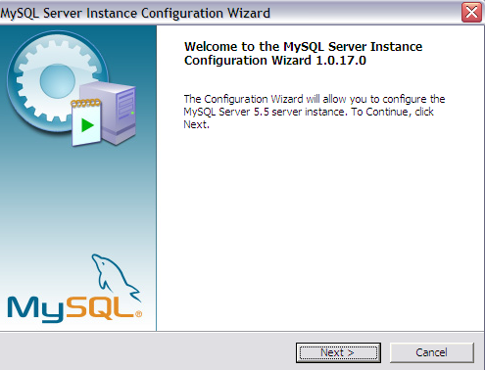

1. Select *‘Detailed Configuration’* and click on ‘*Next*’.

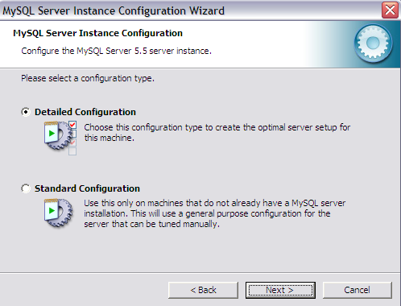

1. Select ‘*Developer Machine*’ option and click on ‘*Next*’.

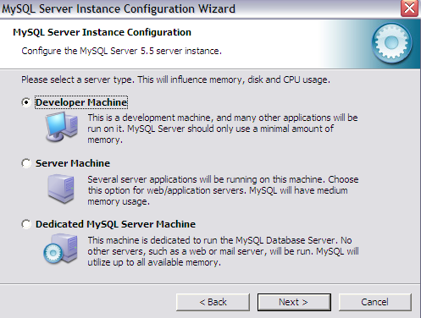

1. Select ‘*Multifunctional Database*’ and click on ‘*Next*’.

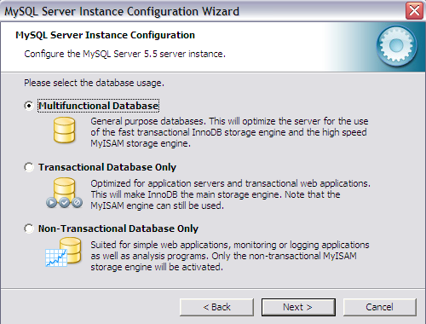

1. Click on ‘*Next*’.

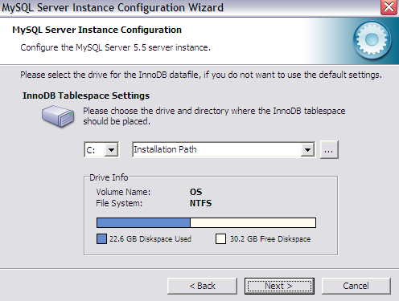

1. Select the ‘*Decision Support’* and required concurrent connections (default is 15). Click on ‘Next’

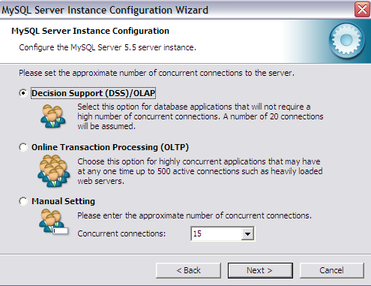

1. Enable TCP/IP Networking and strict mode. Click on *’Next*’.

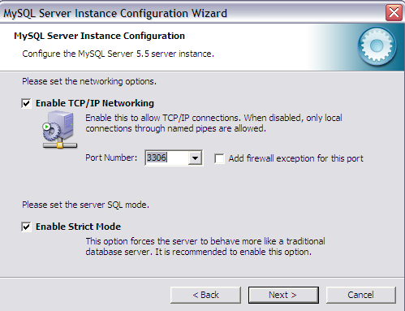

1. Select the ‘*Standard Character Set*’ and click on ‘*Next*’.

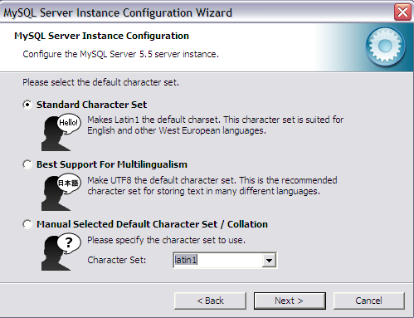

1. Select MySQL Server to install as Windows Service. Click on ‘*Next*’.

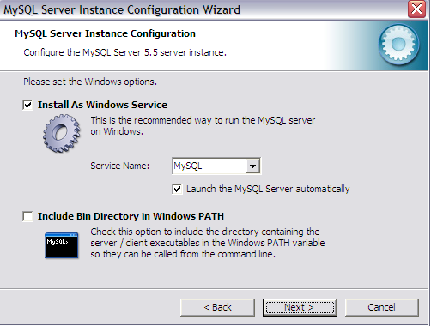

1. Select ‘*Modify security Settings*’ and enter password as ‘***password***’. Click ‘*Next*’.

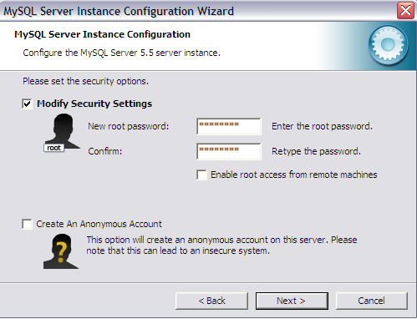

1. Click on ‘*Execute*’ to configure the MySQL server instance.

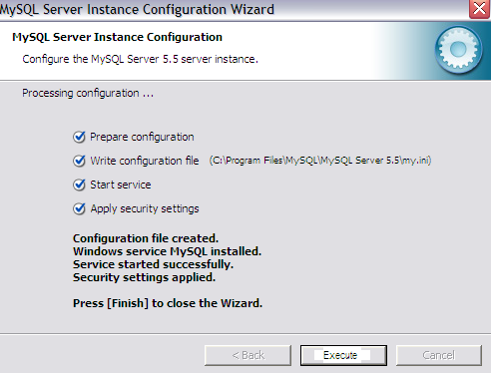

1. Click on ‘*Finish*’, to complete the installation.

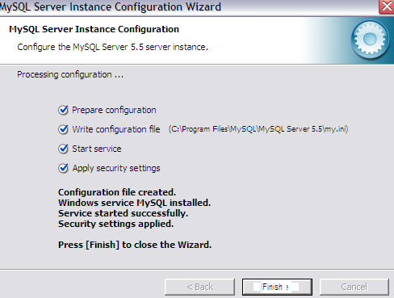

**Launching MySQL 5.5 Command Line Client**

1. Click on Start, programs, MySQL, MySQL Server 5.5, MySQL 5.5 Command Line Client.

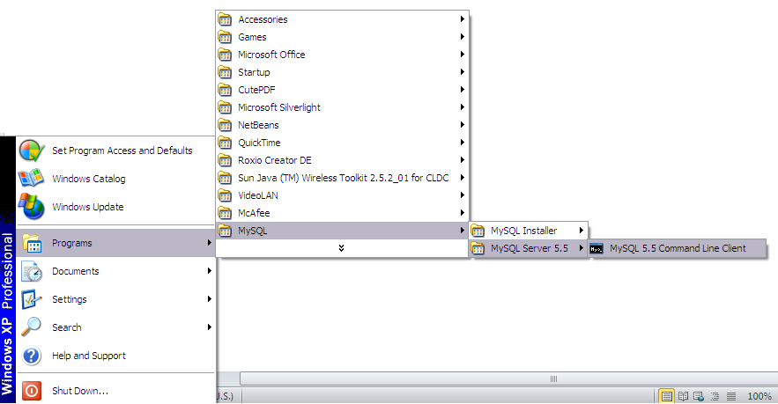

1. Enter the password as ‘password’.

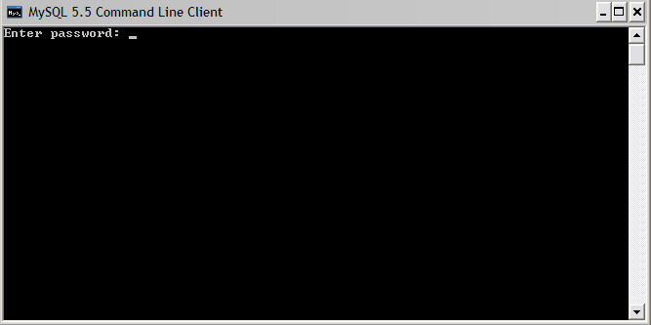

1. Now you are in the command line of MySQL server.

Type ‘exit’ to quit the prompt.

